9.13: a) From Eq. 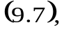 with 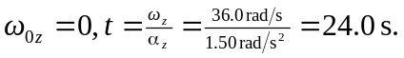
b ) From Eq. 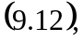 with 